Sai Sindhuja Jampana  Cloud DevOps Engineer/ Site Reliability Engineer  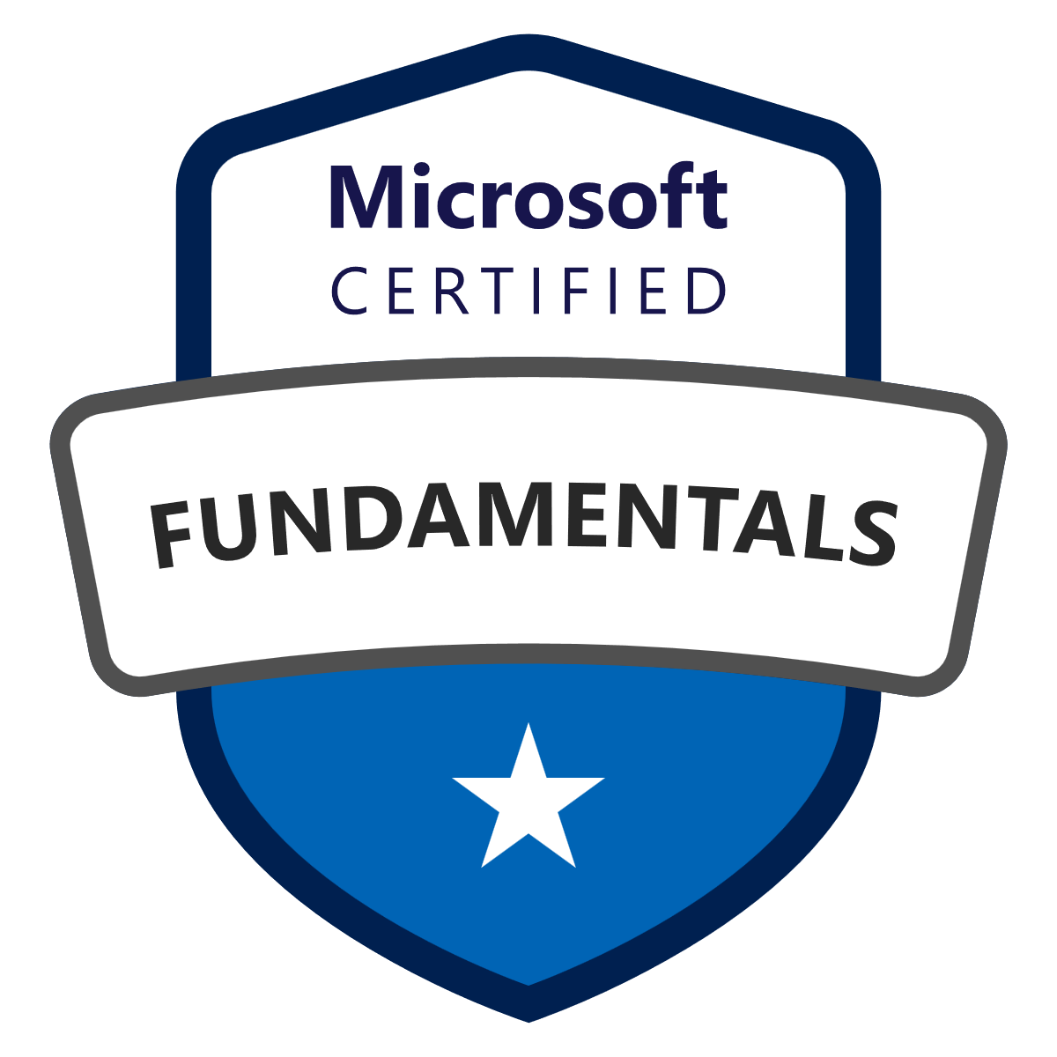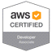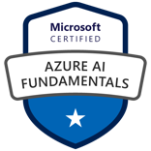 | 8482199977  saisindhujadevops@gmail.com  https://www.linkedin.com/in/saisindhujajampana/

Professional Summary:
- Over 9+ years of experience as a Site Reliability Engineer (SRE) and DevOps Specialist, focusing on observability, infrastructure automation, and system reliability.
- Developed full-stack telemetry pipelines using Python, Influx DB, Grafana, Loki, and integrated real-time alerts with Microsoft Teams and Outlook.
- Created advanced Grafana dashboards, Dynatrace, Kibana, and Splunk visualizations to enhance observability for application performance, infrastructure health, and business KPIs.
- Automated data extraction and ingestion from MSSQL to Influx DB, reducing manual efforts by 60%.
- Deployed and managed Fluentd, Elasticsearch, Loki, and the ELK Stack for log aggregation and time-series monitoring on Windows and Linux platforms.
- Implemented Prometheus and Alert manager with custom queries; integrated alerting into Microsoft Teams and Outlook.
- Designed and deployed CI/CD pipelines using Jenkins, GitHub Actions, and Bamboo for full lifecycle automation of build, test, and deployments.
- Automated tool upgrades, deployment workflows, log retention policies (using ILM), and provisioning of infrastructure with Terraform, AWS CloudFormation, and Ansible.
- Built CI/CD dashboard applications using Python MVC frameworks to enable self-service pipeline control from a web UI.
- Migrated legacy DevOps toolchains to the Atlassian suite: Bitbucket, Bamboo, Jira, and Confluence.
- Managed Docker containers and orchestrated deployments using Kubernetes (EKS, OpenShift), Docker Swarm, and Helm for reusable application deployments.
- Hands-on experience with AWS services including EC2, S3, RDS, Lambda, EKS, ECS, VPC, Route 53, SNS, SQS, and DynamoDB.
- Developed Python scripts and used Apache Airflow for orchestrating ETL workflows and job scheduling.
- Configured RBAC in Kibana and integrated SSO and Active Directory for secure access to Docker and ELK environments.
- Used JFrog Artifactory for artifact management with LDAP/SAML-based access control.
- Scheduled jobs and managed automation tasks in Ansible Tower integrated with Bitbucket.
- Performed Linux server performance tuning and troubleshooting using tools like top, htop, vmstat, and iostat.
- Defined SLIs/SLOs based on historical monitoring data to drive system reliability improvements.
- Led incident management, post-incident reviews, and ensured SLA compliance with corrective action implementation.
- Worked extensively with ServiceNow, Opsgenie, Jira Service Desk, and ITSM Remedy for change, incident, and on-call management.
- Partnered with cross-functional teams to onboard applications to observability tools and improve operational visibility.
- Created runbooks/playbooks to support L1/L2 teams in resolving ELK, Prometheus, and telemetry-related issues.
- Implemented static code analysis, vulnerability scans, and notifications in Jenkins for enhanced CI automation.
- Led monitoring discovery and pilot initiatives to create dashboards tracking infrastructure and application availability in near real-time.

Education:
- Jawaharlal Nehru Technological University (JNTU), Hyderabad, India | Bachelor of Technology (B. Tech) in Computer Science & Engineering Aug 2010 – 2014
- New York Institute of Technology, New York, US | Master of Science (M.S) in Computer Science
Certifications
- AWS Certified Developer Associate Issued: June 2017
Validation Number: VMCMD7121B44QTKR
- Microsoft Azure Fundamentals Issued: May 2024
Credential ID: 2152692F10A2B039
- Microsoft Azure AI Fundamentals Issued: November 2024
Credential ID: 28201729F3CB93D1
- Hashi Corp Certified: Terraform Associate (003) Issued: Oct 2024
Certificate Number: add2bd63-248b-4abf-866a-e776c9da2749

- Certified Agile Scrum Master Issued: Dec 2024
Certificate Number: ub4bipokhq
https://www.hrduniversity.org/certificates/ub4bipokhq

Technical Skill Set:
Observability & Monitoring | Grafana, Influx DB, Prometheus, Loki, Fluentd, Dynatrace, Splunk, ELK Stack (Elasticsearch, Logstash, Kibana), Kibana, Microsoft Teams, Outlook
Scripting & Automation | Python, Bash, PowerShell, Ansible, Apache Airflow, Jenkins, GitHub Actions, Bamboo, Docker Compose
CI/CD & DevOps Tools | Jenkins, GitHub, Bitbucket, GitLab, Bamboo, Maven, ANT, Nexus, JFrog Artifactory, Ansible Tower
Version Control | Git, Bitbucket, Subversion (SVN)
Cloud Platforms | AWS (EC2, S3, RDS, Lambda, EKS, ECS, VPC, Route53, SNS, SQS, DynamoDB, Glacier), Red Hat OpenShift
Infrastructure as Code (IaC) | Terraform, AWS CloudFormation
Containerization & Orchestration | Docker, Docker Swarm, Kubernetes (EKS), Helm, OpenShift
Logging & Alerting | ELK Stack, Loki, Prometheus Alert manager, Fluentd, ILM, Kibana RBAC, Email, Slack, Microsoft Teams notifications
Database & Data Ingestion | MSSQL, Influx DB, Elasticsearch, S3, Glacier, DynamoDB
Security & Access Control | RBAC, SAML, LDAP, AD Authentication, SSO
Monitoring Automation | Custom Grafana Dashboards, Prometheus Queries, Alert Rules, Jenkins Notifications, Jira Service Desk Triggers
Incident & Change Management | ServiceNow, Opsgenie, ITSM Remedy, Jira Service Desk, MIR3
ETL & Data Pipelines | Apache Airflow, Python, MSSQL, Influx DB, Elasticsearch
Web Development (Internal Tools) | Python MVC Frameworks, CI/CD Web UI for Pipelines
System Administration | Linux Performance Tuning (top, htop, vmstat, iostat, netstat), Log Analysis
Build & Release Management | Jenkins Pipelines, GitHub Actions, Maven/ANT Builds, CI/CD Automation, Artifact Packaging
Collaboration & Documentation | Confluence, Jira, Agile Central, Email/Slack Integration, Post-Incident Reviews
Application Monitoring & SRE | SLI/SLO Definitions, Real-time Alerts, Root Cause Analysis, FITEST POC, SREEXCELLENCE Dashboards
Backup & Storage | S3, Glacier, ILM Policies, Snapshot Management
Scheduling & Job Orchestration | Ansible Tower, Apache Airflow, Jenkins Job Scheduling

Employment history
Americold Logistics LLC | Senior DevOps Engineer / SRE, Atlanta, GA Mar 2024 – Current
Responsibilities:
- Created Grafana Dashboards to visualize warehouse telemetry data insights, configure alerts, and notification systems, significantly improving monitoring capabilities and enabling proactive issue resolution.
- Developed a full-stack telemetry pipeline using Python, InfluxDB, Grafana, and Loki to visualize application performance and generate real-time alerts via Microsoft Teams and Outlook.
- Developed Python scripts to automate the extraction of data from MSSQL, transforming and ingesting it into InfluxDB, resulting in a 60% reduction in manual data processing efforts.
- Installed and machines from scratch, establishing a robust analytics and monitoring framework for cross-platform compatibility.
- Worked with Elasticsearch APIs for health checks, diagnostics, and custom index/query tuning.
- Implemented Apache Airflow to run Python scripts automatically by creating job flows, streamlining ETL processes and ensuring timely and accurate data updates.
- Installed and configured Fluentd on Windows machines to collect and forward logs and metrics to InfluxDB, enabling seamless data ingestion for time-series analysis and custom monitoring solutions.
- Installed and configured Loki on Windows machines and utilized Python scripts to extract data from Elasticsearch and ingest it into Loki. Configured Grafana data sources and visualizations based on business rules, enhancing log analysis and monitoring capabilities.
- Creating S3 buckets and managing policies for S3 buckets and utilized S3 bucket and Glacier for storage and backup on AWS.
- Involved in designing and deploying multitude applications utilizing almost all the AWS stack (Including EC2, Load Balancer, S3, RDS, DynamoDB, SNS, SQS, Lambda, IAM) focusing on high-availability, fault tolerance, and auto-scaling in AWS Cloud Formation.
- Developed tasks in InfluxDB to read and process data from gantry cranes and loops using business rules, optimizing data management and operational decision-making.
- Led the discovery and pilot phase to conceptualize a dashboard for monitoring the availability of automated machinery, IT infrastructure, warehouse applications, and operational KPIs in near real-time, enhancing visibility and operational efficiency.

JPMorgan Chase | Site Reliability Engineer | Columbus, Ohio Dec 2022 - Dec 2023
Responsibilities:
- Defined Service Level Indicators (SLI’s) and Service Level Objectives (SLO’s) which are achievable with the historical monitoring data for Applications.
- Collaborated with the different application teams for onboarding the applications to new monitoring tools and responsible for setting up the proactive monitoring.
- Created the Dynatrace dashboards for the application monitoring by application team and
- the business team.
- Developed and maintained Splunk dashboards and alerts to monitor application and infrastructure performance across multi-environment deployments.
- Performed Incident management for high priority incident by sending out the reach comms and collaborating with different teams and working on the resolution without breaching the SLAs.
- Led post-incident reviews to analyze the root causes of major incidents and implemented corrective actions to prevent recurrence.
- Triaging and diagnosing the performance issues and escalating internal system alerts to the respective teams to ensure that application maintain their SLA (Service Level Agreement)
- Responsible for writing the Prometheus queries for creating the latency and availability checks in SERVICE STATUS and for tracking in the SREEXCELLENCE dashboard.
- Did POC on FITEST (functionality testing) and leveraged for SRE Monitoring of Various Applications.

Thrivent Financial | DevOps Engineer | Appleton, WI Aug 2018 - Dec 2022
Responsibilities:
- Led the migration of DevOps tools to the Atlassian Development Tools Suite, transitioning from Subversion (SVN) to Bitbucket, Jenkins to Bamboo, Agile Central to Jira, and introducing Confluence, which streamlined collaboration and improved project management efficiency.
- Created and maintained data parsing templates and index patterns to ensure structured log analysis and correlation in Kibana.
- Utilized ELK Stack (Elasticsearch, Logstash, Kibana) to troubleshoot and analyze logs of Dockerized applications, enabling faster root cause analysis and proactive issue resolution.
- Implemented and managed Prometheus with Alert manager, integrated with outlook and Microsoft Teams to send real=time alerts for Docker application errors and node-level CPU/Memory thresholds, improving system reliability and incident response.
- Set up role-based access control (RBAC) in Kibana to allow secure access to dashboards by various stakeholders.
- Designed Jenkins pipelines to orchestrate end-to-end automation of code integration, testing, artifact packaging, and multi-environment deployment.
- Deployed and managed Docker Containers and Kubernetes Clusters on Linux Servers.
- Upgraded ELK Stack (Elasticsearch, Logstash, Kibana) to meet N-1 compliance, automating the upgrade process using Ansible, ensuring consistency across environments and minimizing downtime.
- Managed Kubernetes cluster lifecycle including provisioning, upgrading, and scaling on AWS.
- Created and maintained custom CI/CD workflows using GitHub jeto automate build, test, and deployment processes for applications.
- Created Kibana dashboards to visualize trends, identify bottlenecks, and detect anomalies in Dockized microservices, improving visibility for dev and ops teams.
- Implemented log retention policies and index lifecycle management (ILM) in Elasticsearch to optimize storage and performance.
- Integrated application logs from multiple environments (dev, test, prod) into a single ELK instance, enabling unified observability.
- Automated the deployment of Prometheus and ELK components using Ansible and Docker Compose, ensuring reproducible infrastructure setup.
- Created runbooks/playbooks for ELK and Prometheus incidents, aiding L1/L2 support teams in triage and first response
- Performed system troubleshooting on Linux servers for log analysis and performance tuning using tools such as top, htop, iostat, vmstat, and netstat.
- Managed and maintained JFrog Artifactory as a central repository for storing Maven, npm, Docker, and Python (PyPI) artifacts across multiple environments.
- Performed maintenance and troubleshooting of our enterprise red hat OpenShift systems.
- Integrated Terraform with Bamboo CI/CD pipelines to enable automated infrastructure deployment, improving deployment consistency across multiple environments (dev, staging, prod)
- Built a multistage Docker file to containerize the application, reducing image size and enhancing security.
- Created Kubernetes manifests (Deployment, Service, Ingress) and deployed the application on AWS EKS.
- Configured SSO for on-prem applications and AD Authentication for Docker Engine.
- Designed Helm charts to package and deploy the application for better scalability and reusability.
- Worked with RedHat OpenShift container platform for Docker and Kubernetes, used Kubernetes to manage containerized applications.
- Configured python script to develop an internal application using MVC Framework to create CI/CD pipeline from the UI.
- Integrated JFrog Artifactory with LDAP/SAML for user and group-based access control, improving security and audit compliance.
- Worked with python virtual environment and troubleshooted issues related to pip while doing tool upgrades.
- Scheduling jobs for regular automation tasks in Ansible Tower, ensuring automation happens at the right time without manual intervention.
- Integrating Ansible Tower with version control systems like Bitbucket for playbook management and setting up notifications for job success, failure, or status updates via email.
- Extensive experience in Server infrastructure development on AWS Cloud by using AWS services like EC2, ECS, EBS, ELB, Lambda, S3, RDS, Glacier, DynamoDB, VPC, Route53,
- Using Terraform deployed AWS resources like EC2, EFS, VPC, RDS, EBS, Elastic Load Balancer, Auto scaling groups, S3, SQS, SNS, SES, Lambda, and etc.
- Troubleshooting application build and deployment failures by working with App-Dev and Infrastructure teams as part of the delivery process.
- Setting up the on-call schedule calendar in Opsgenie and in MIR3.
- Worked with ServiceNow and ITSM remedy (change management Ticket System) recently to create tickets for production deployments.
- Setting up an Alert/trigger in Jira service Desk, which will send an email to Devops group when there is a ticket unassigned or in progress ticket is not closed after 3 hours of getting assigned.
- Provided IT monitoring solutions for server infrastructure, web applications and stand-alone applications by working with third party vendors for 24/7 NOC support.

CDx Diagnostics | DevOps Engineer | Suffern, New York Dec 2015 - Aug 2018
Responsibilities:
- Integrated GIT with Jenkins for CI, reducing integration times by 20% and streamlining processes.
- Developed CI/CD systems with Jenkins, ANT, and Maven, boosting deployment frequency by 30%.
- Created and maintained custom Jenkins jobs for automated code build, test, and deployment processes.
- Designed Jenkins workflows for CI/CD, enhancing reliability and cutting deployment errors by 25%.
- Led Docker Swarm orchestration, optimizing container management and improving scalability.
- Automated deployments with Ansible, cutting manual tasks by 50% and enhancing efficiency.
- Spearheaded container orchestration with Docker Swarm, enhancing application scalability and reliability while optimizing resource management.
- Integrated static code analysis, security scans and artifacts upload into Jenkins jobs for end-to-end CI Automation.
- Implemented notifications and alerting in Jenkins jobs via email, Slack, and Microsoft Teams for build and deployment status updates.
- Implemented CI/CD systems using Jenkins and Python, significantly boosting deployment frequency and streamlining the software delivery process.
- Developed custom Docker images and managed container-based deployments, improving deployment speed and ensuring efficient resource utilization.
- Partnered with cross-functional teams to develop automation tools, substantially reducing release cycle times and enhancing overall productivity.
- Integrated GIT into CI environment, optimizing version control and build processes, resulting in notable reduction of integration times.
- Pioneered Docker Swarm orchestration, revolutionizing container management and substantially enhancing application scalability and resource utilization.

